**Azure Cost Management**

**Notes: -**

**1-Azure Management cost (ACM) designed for the following: -**

**A-Management: responsible for budgets and bottom line.**

**B-Finance Users: responsible for managing funds, create budgets and enforcing compliance & governance**

**C-App teams: who used these services**

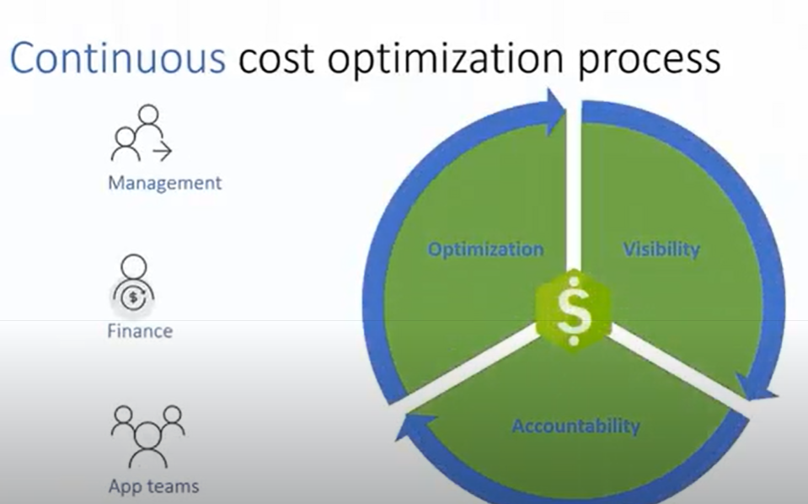

**1-Visisbility: where the charges coming from, how to relate to your invoices**

**2-Accountability: for make sure that the teams responsible for the charges, and make accountable for them, and that they stay on the budget**

**3-Optimization: reducing cost by identify wastage and optimizing resources & VM size**

**And optimize cloud resources usage**

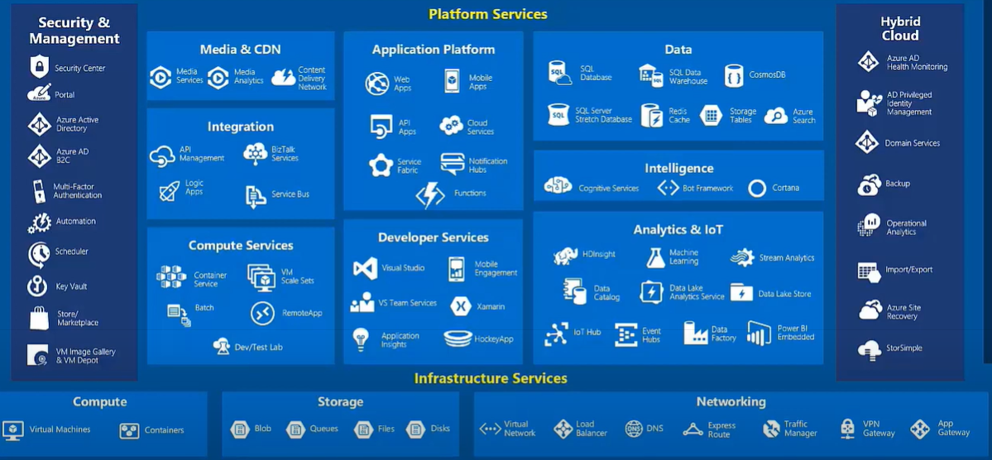

**Azure Seperation Coste**

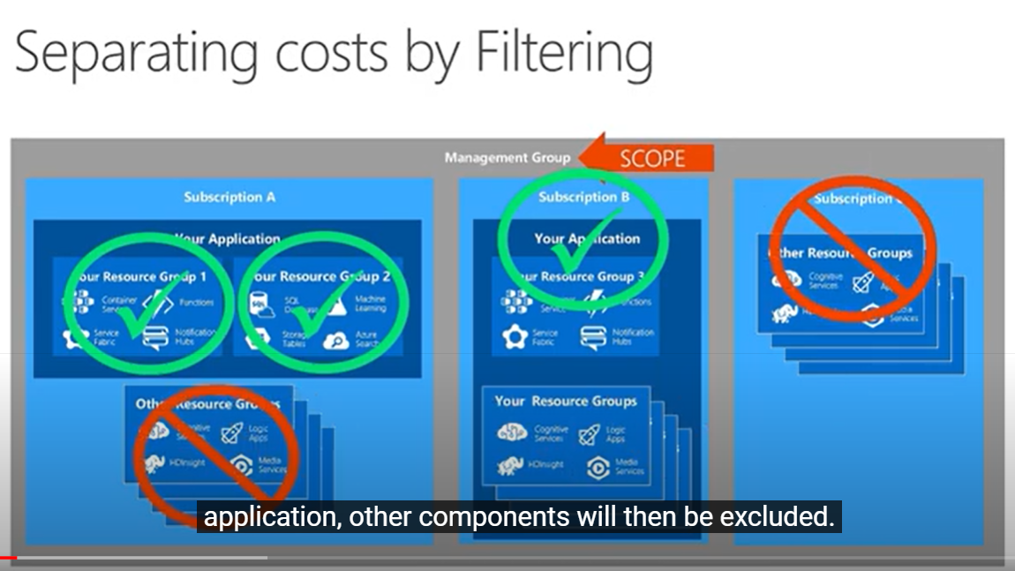

**You can enable / disable resource group on the same / different azure subscription to reduce cost**

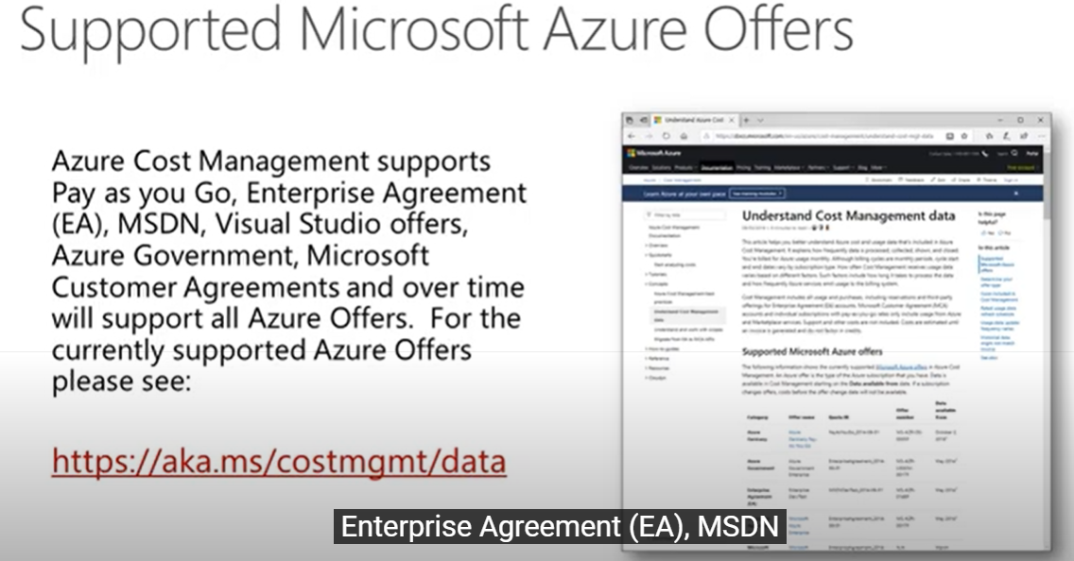

**Steps: -**

**1-on Azure Portal > Cost Management > Cost analysis**

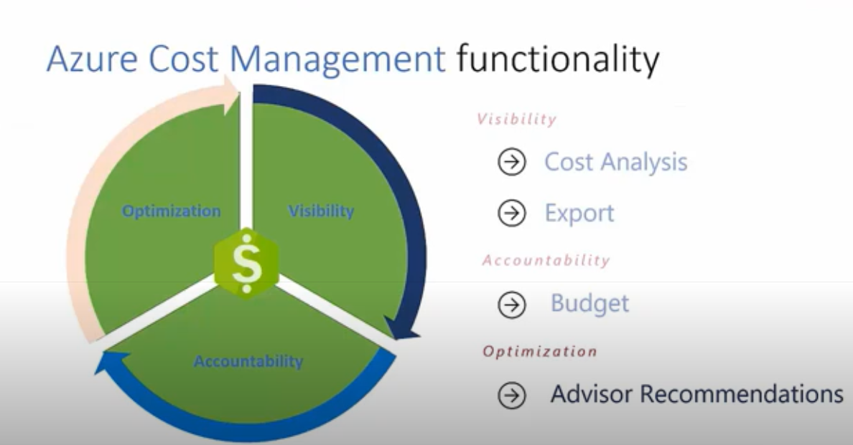

**2-you can select Scope you want and click search , then you see the cost**

**(scope means resource group , and you can see each developer what resource cost take)**

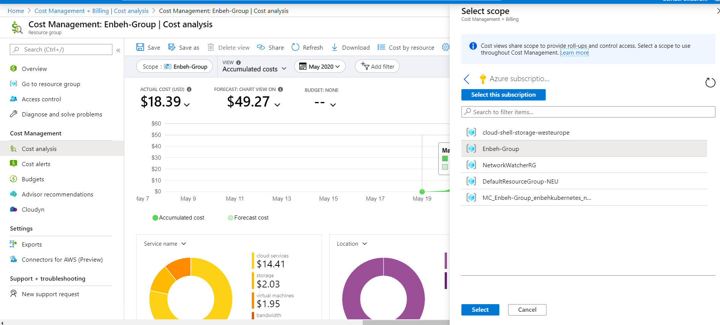

**3-you can filter on specific date range or specific day which resource consume money**

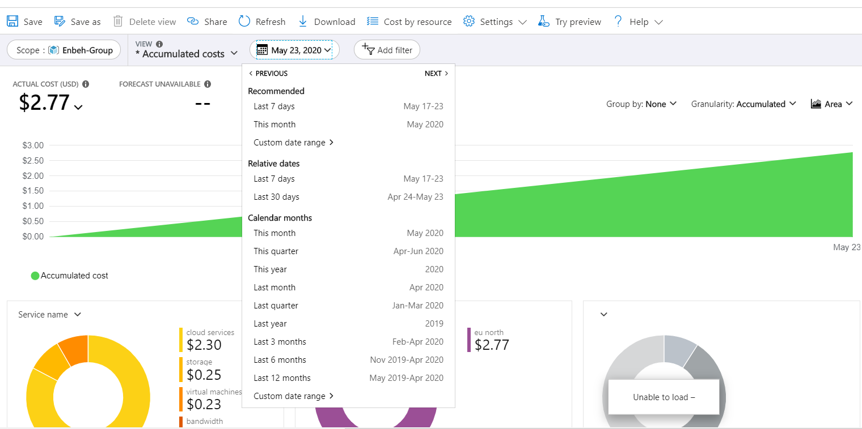

**4-you can save the Cost management and export it**

**5-you can make grouping by resource group name and Grouping Daily which represent you each day on each resource group name how much money spent**

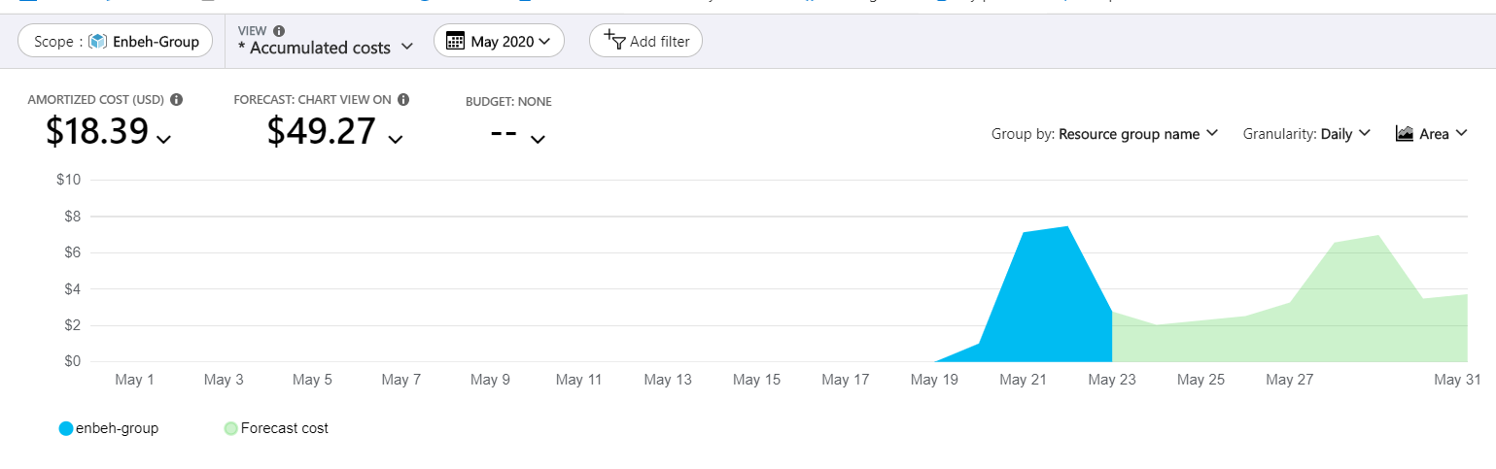

**6-when export the cost management analysis you can schedule export daily / weekly,and select the storage account name which export has saved into the container**

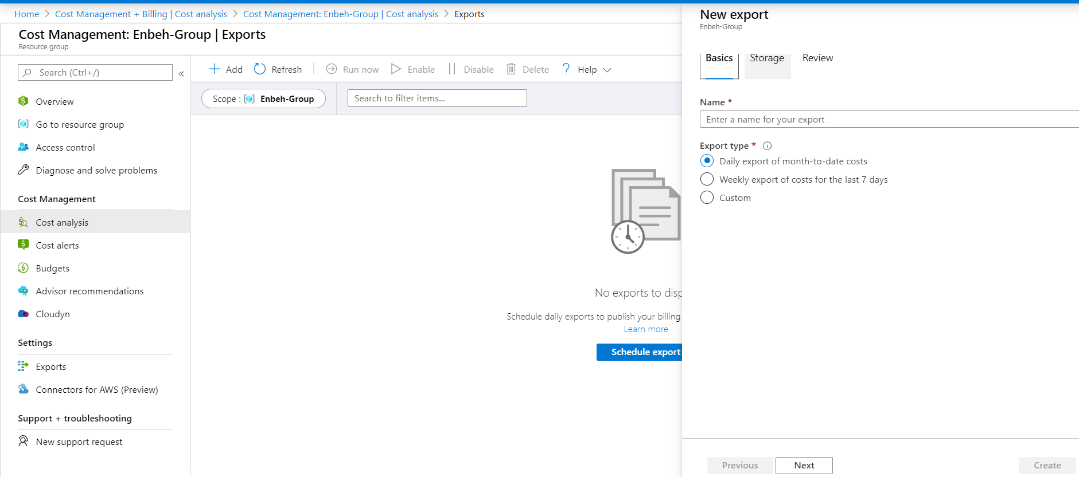

**7-you can create budget to keep track of budget funds and hold stackholders accountable for their cloud spend**

**By select the scope you target on it and set the budget alert when the value exceed specific percentage and send email to target users when the alert happen**

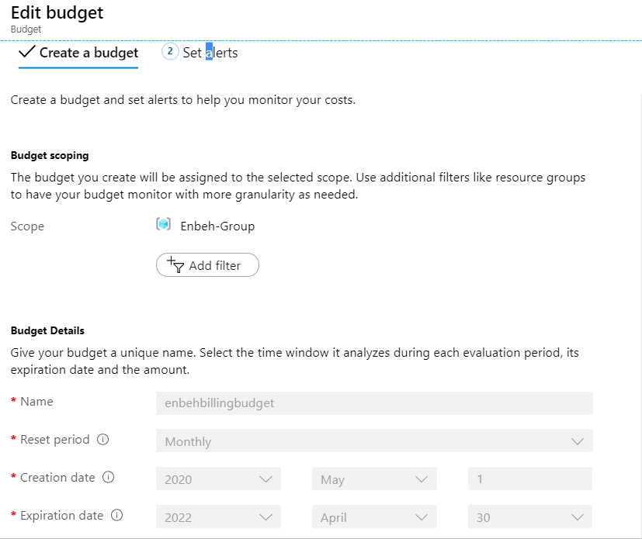

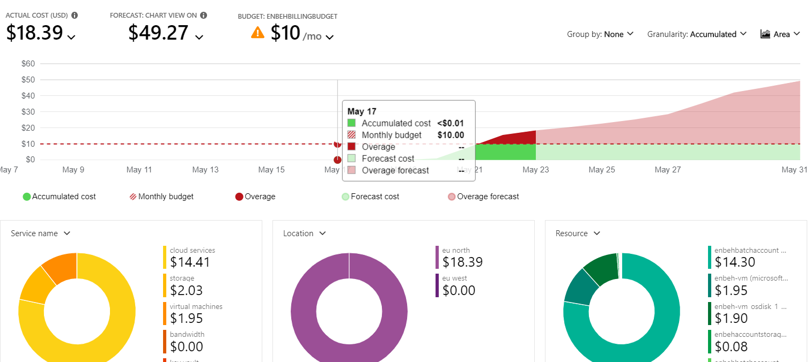

**3-Advisor Recommendation**

**Which used to see recommendation about when high usage like VM and each one can show analytic on each recommendation how to reduce cost**

